Press Clipping

Client: Fortinet Date: April – May 2012
Circulation: 5,360
Publication: CIO Asia Page: 14
Page 1 of 14

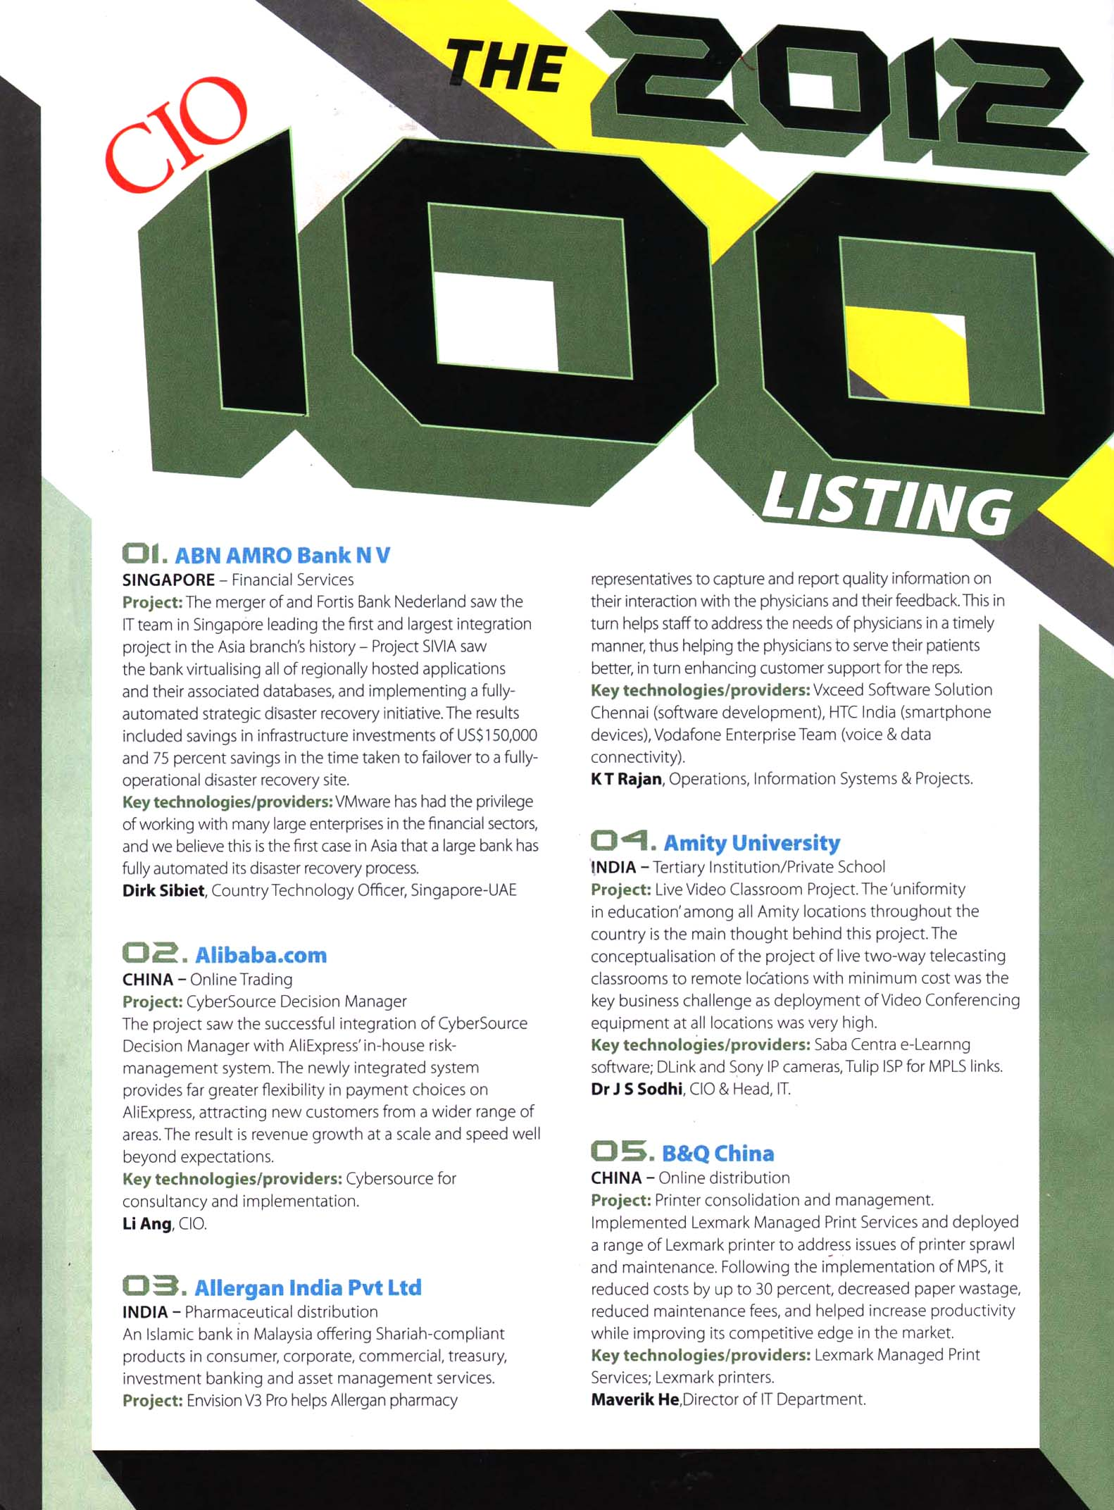

Press Clipping

Client: Fortinet Date: April – May 2012
Circulation: 5,360
Publication: CIO Asia Page: 16
Page 2 of 14

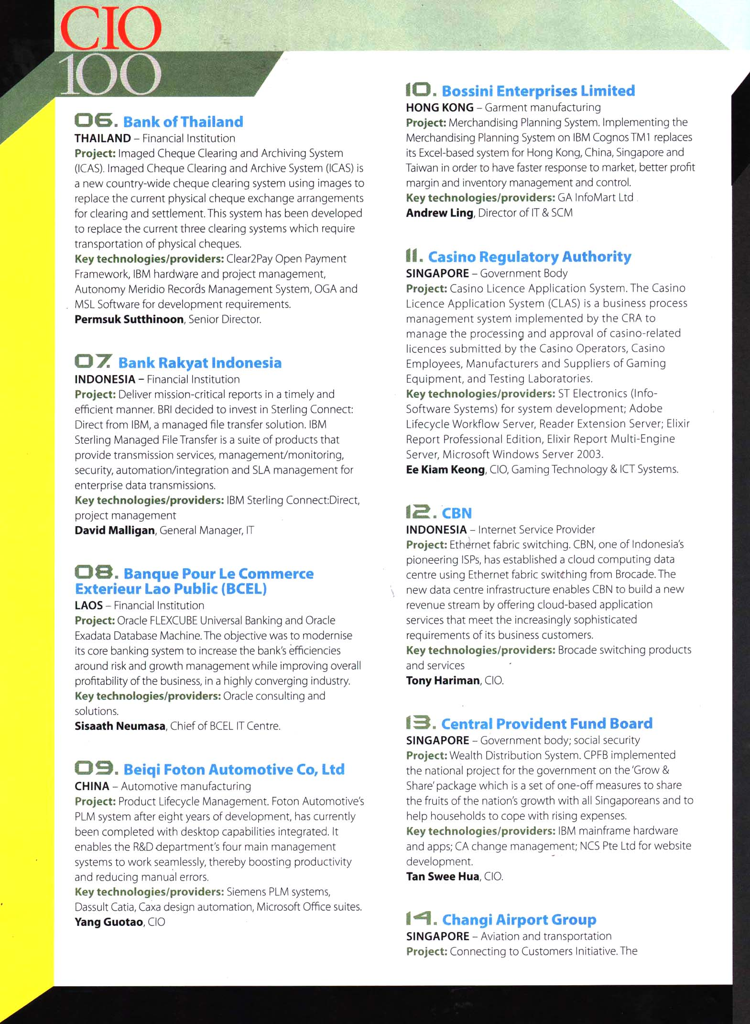

Press Clipping

Client: Fortinet Date: April – May 2012
Circulation: 5,360
Publication: CIO Asia Page: 17
Page 3 of 14

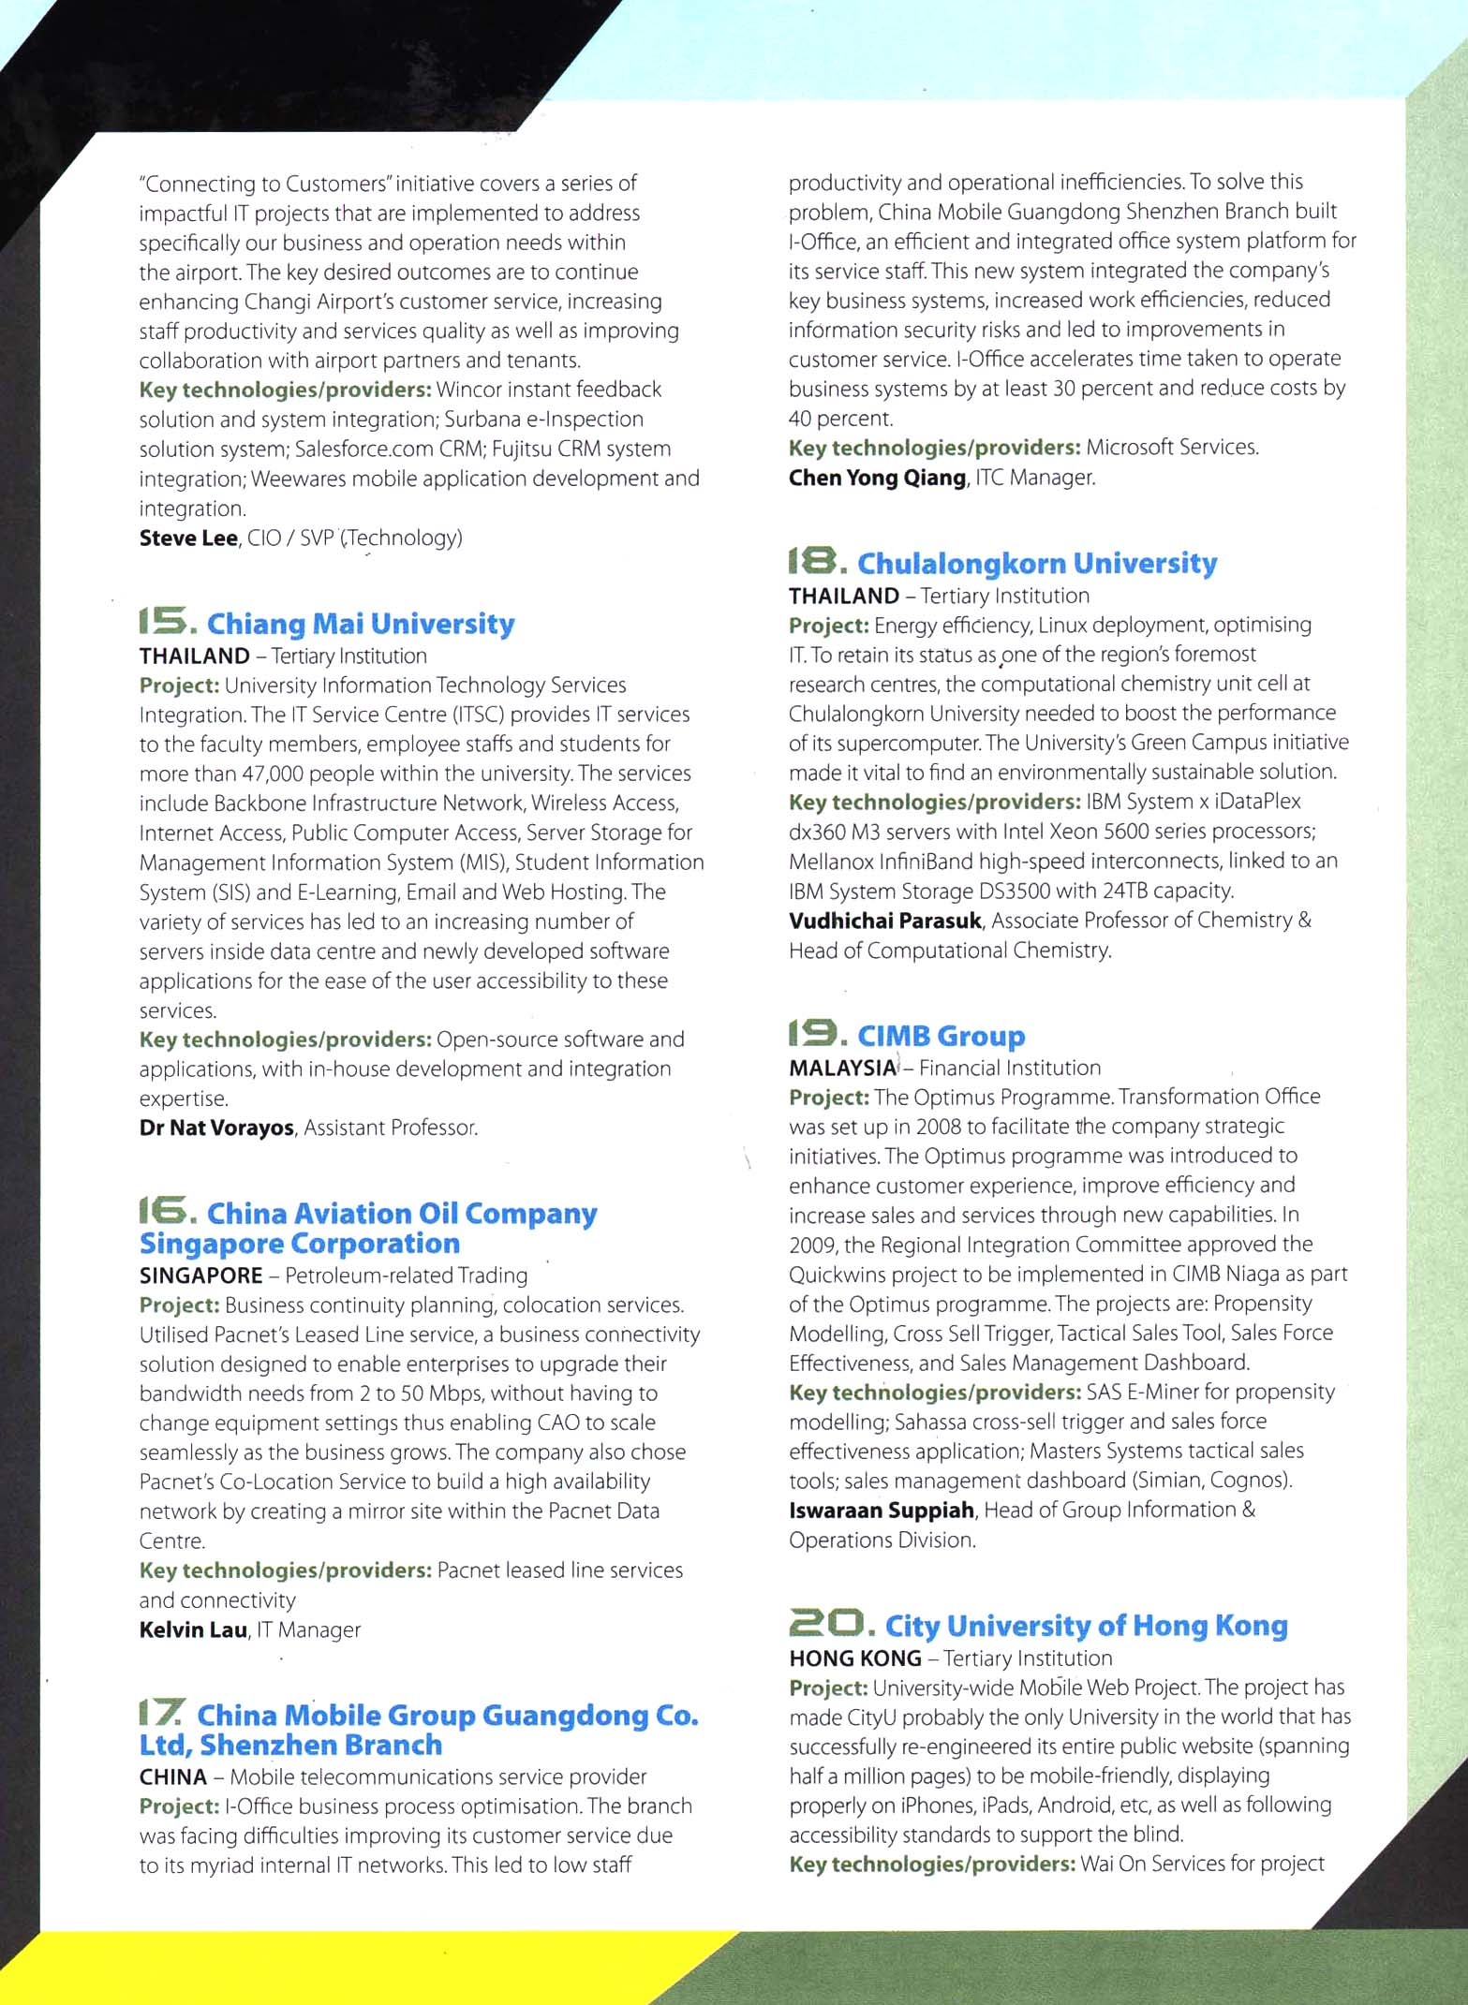

Press Clipping

Client: Fortinet Date: April – May 2012
Circulation: 5,360
Publication: CIO Asia Page: 18
Page 4 of 14

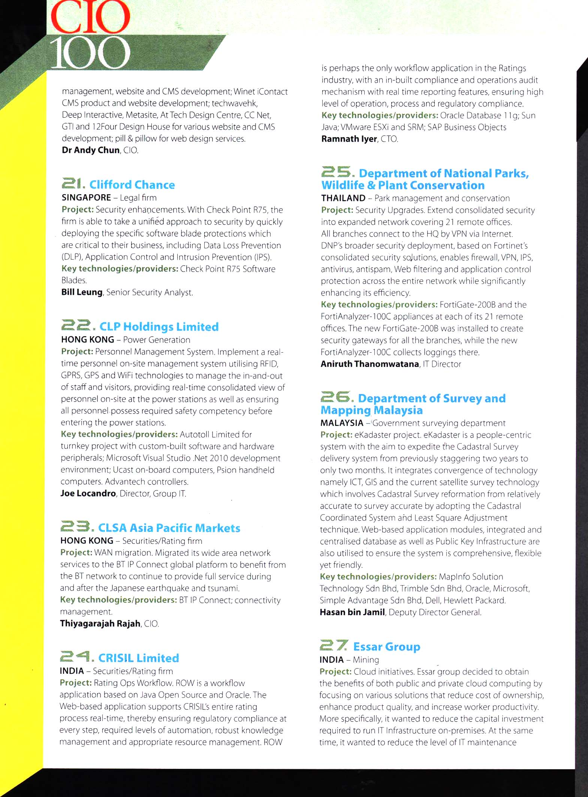

Press Clipping

Client: Fortinet Date: April – May 2012
Circulation: 5,360
Publication: CIO Asia Page: 19
Page 5 of 14

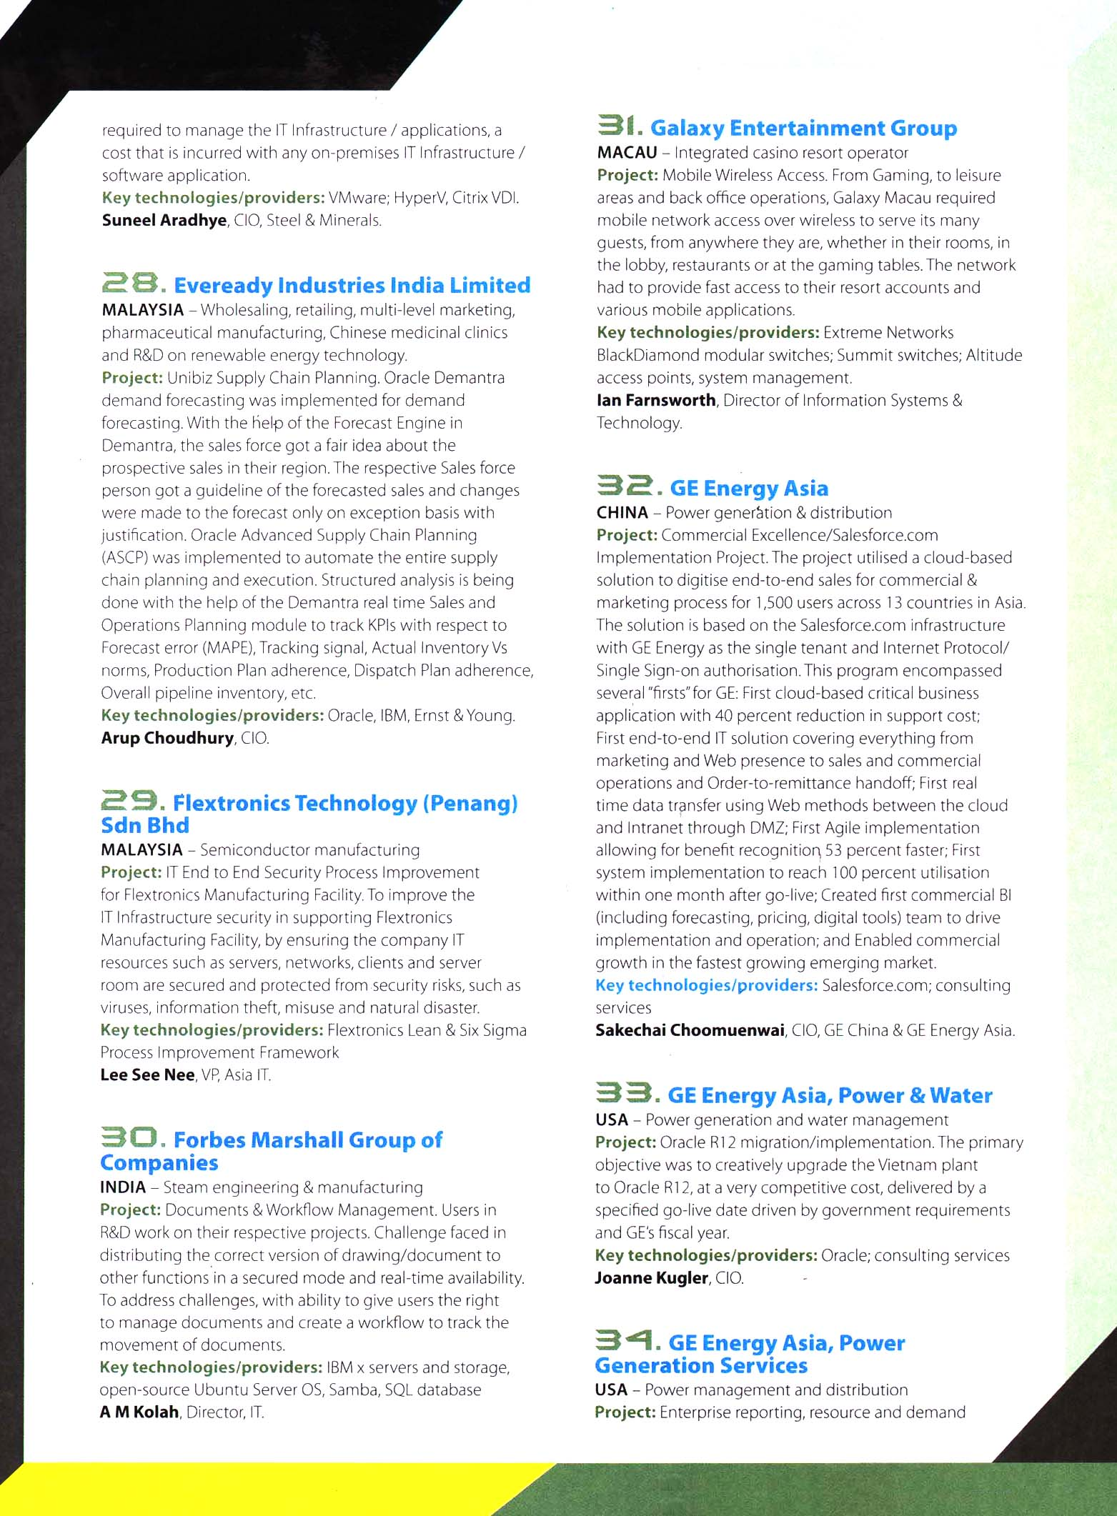
Press Clipping

Client: Fortinet Date: April – May 2012
Circulation: 5,360
Publication: CIO Asia Page: 20
Page 6 of 14

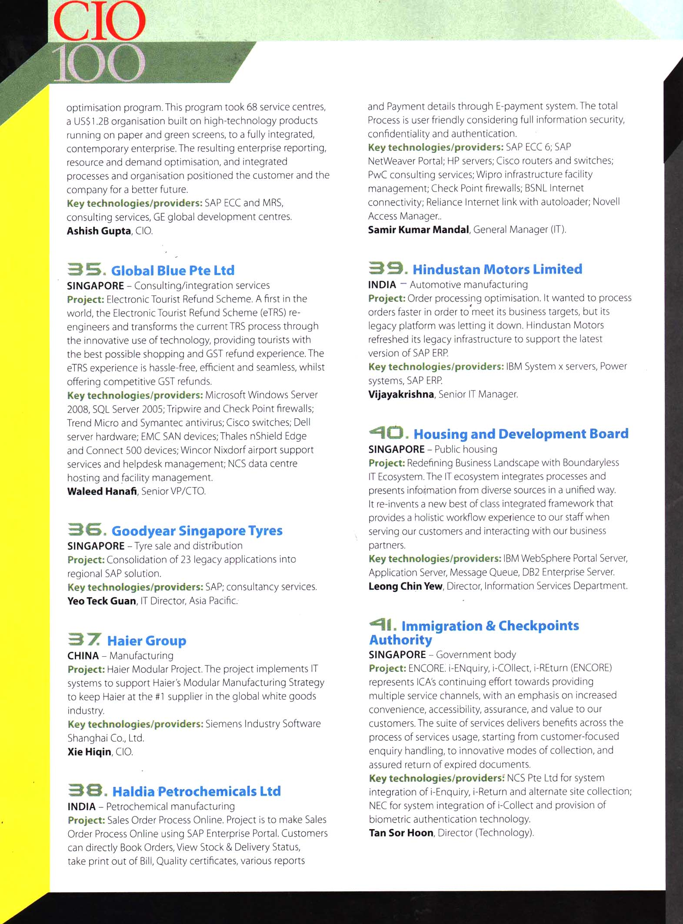

Press Clipping

Client: Fortinet Date: April – May 2012
Circulation: 5,360
Publication: CIO Asia Page: 21
Page 7 of 14



